PENGAJUAN DANA

1. TOWING RUBICON B568ALD (VIA TELFON)
2. SISA SERVICE FERRARI CALFORNIA TRANSMISI MOUNTING

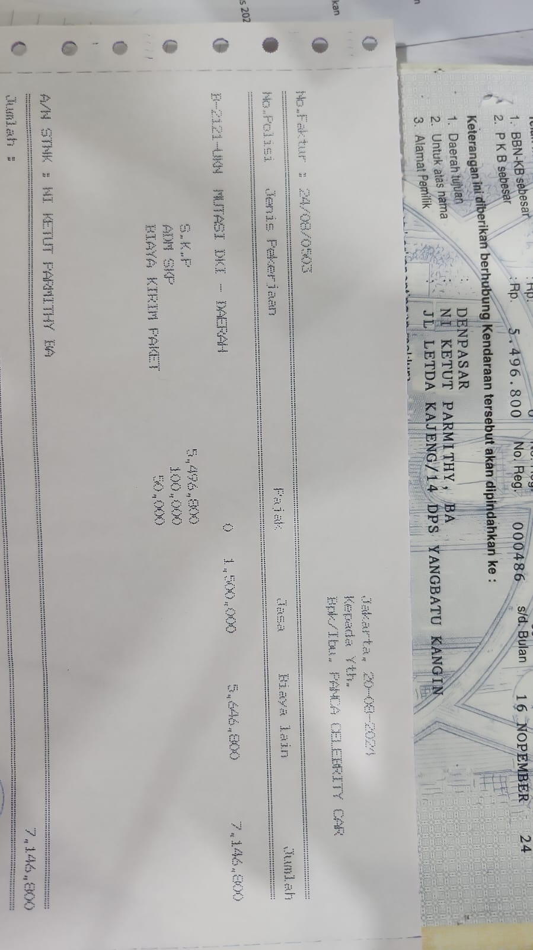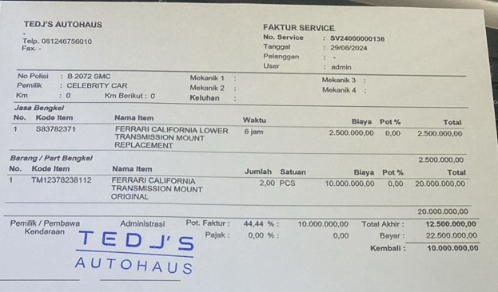

1. CABUT BERKAS TOYOTA VOXY B 2121 UKN
2. CABUT BERKAS SUZUKI X-OVER OM ANTO

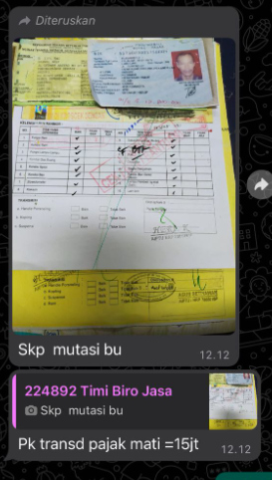

1. BELI PIA ASEP DAN IRENE
2. CAT FERRARI MERAH CALIFORNIA

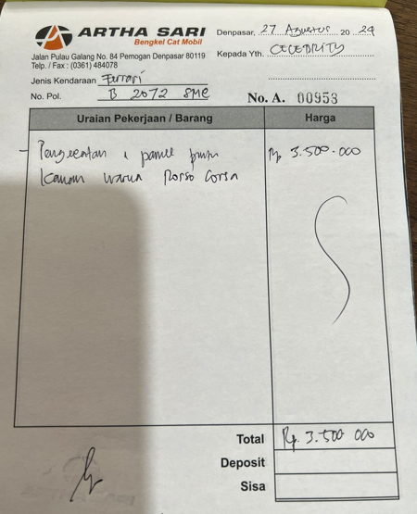

1. 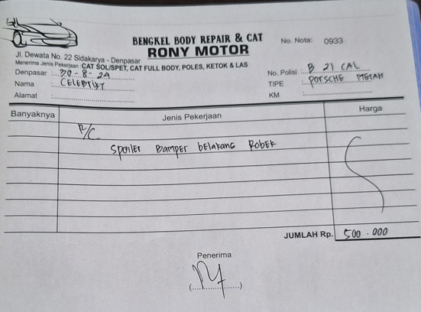CAT PORSCHE PAK FAISAL B 21 CAL
2. GANTI OLI JEEP RUBICON 2015 B 1454 EUY

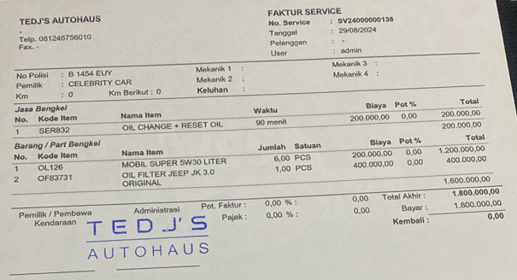

1. SURAT JALAN (ALPHARD PAK RENO & JEEP RUBICON 2015 B 1454 EUY)(VIA TELFON)